
MOINDJIE Daïf
ING-2 IT-SE
18/09/2026

Docker Containers Lab 1

  - Basics
The following screenshot is after the creation of the tp1 folder and the Dockerfile which is exactly as in the subject:
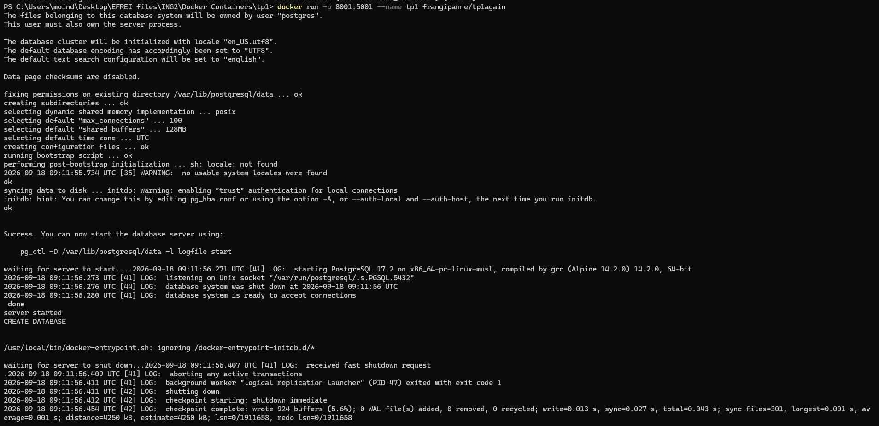
After that I checked if it worked correctly with docker port in another terminal because I had forgotten to add -d:
Creation of the network:
Re-running with adminer (I changed the ports partway through while messing with the flags because it wasn’t working for a while):
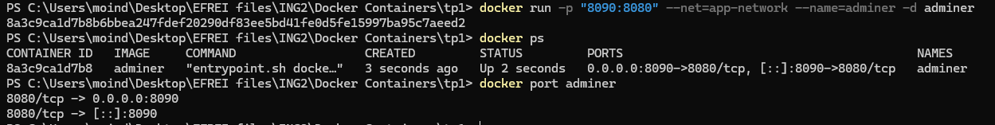
1-1: Because leaving the confidential data in the Dockerfile can lead to the leaking of that data if that file is public.
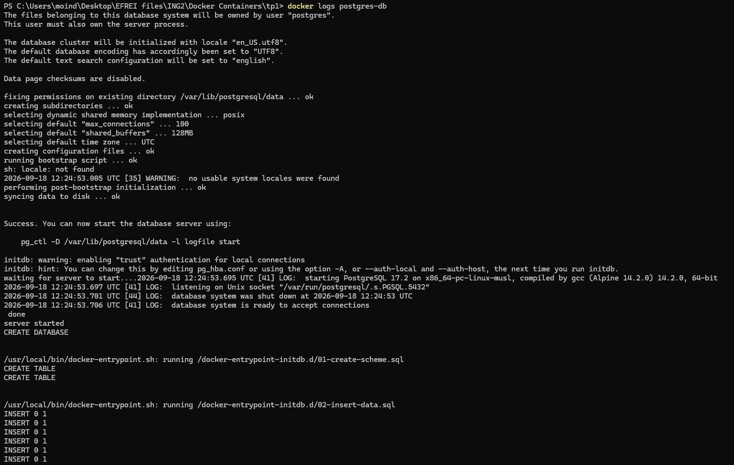
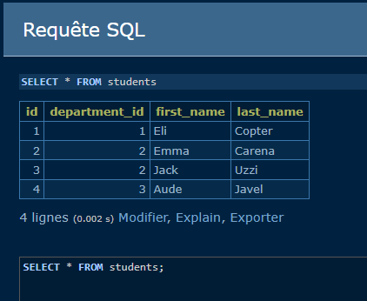
Persist data test:
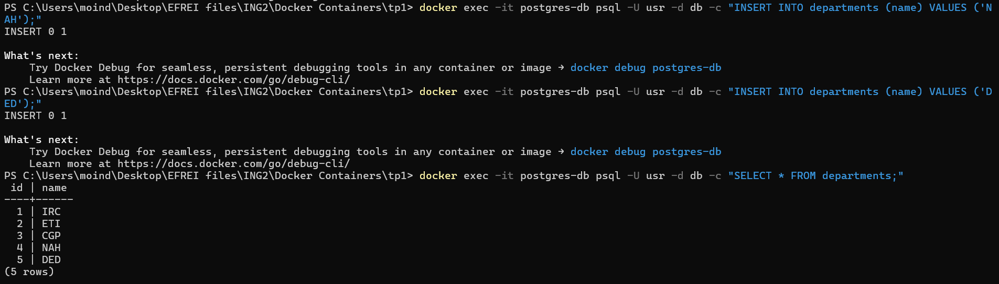
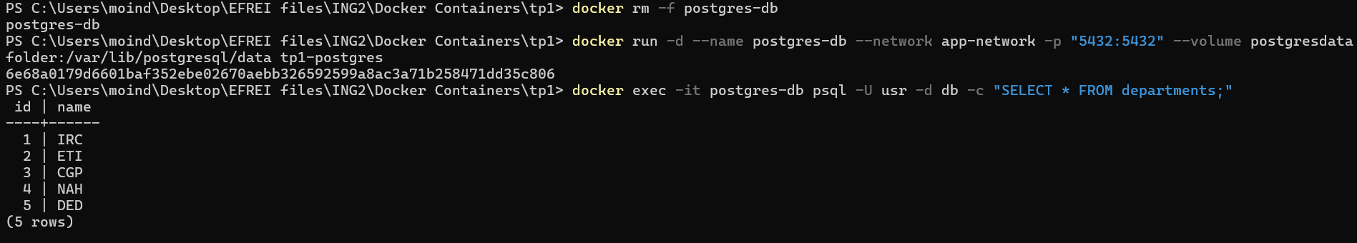
1-2: so that our data doesn’t get lost when we destroy our containers
1:3:
Dockerfile:
FROM postgres:17.2-alpine
ENV POSTGRES_DB=db \
POSTGRES_USER=usr \
POSTGRES_PASSWORD=pwd
COPY CreateScheme.sql /docker-entrypoint-initdb.d/01-create-scheme.sql
COPY InsertData.sql /docker-entrypoint-initdb.d/02-insert-data.sql

Commands:
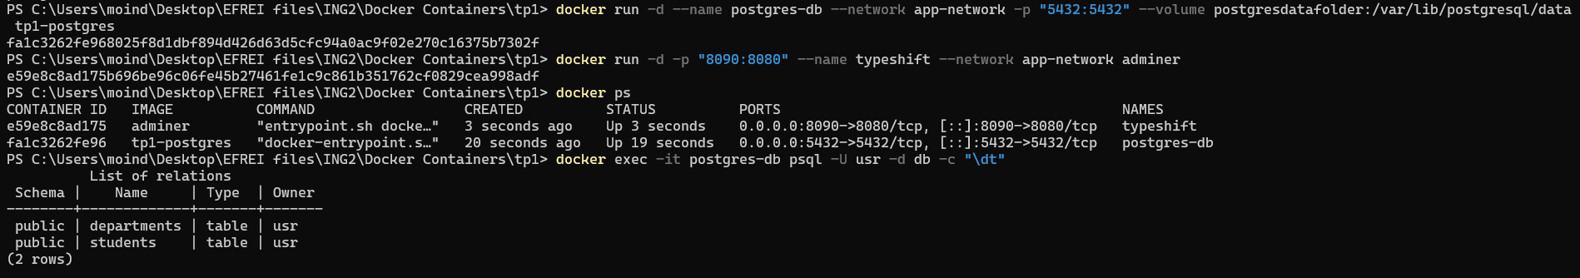

  - Backend API
FROM eclipse-temurin:21-jre
ADD Main.class .
CMD ["java", "Main"]

(changed terminal this time I’m using Intellij IDEA)

